Name : Tushar Pathak
RegNumber : 230905396
Roll Number: B48

Lab 5: Programs on arrays in CUDA

Q1)Write a program in CUDA to add two vectors of length N using
a) block size as N
b) N threads

Code:
#include "cuda_runtime.h"
#include "device_launch_parameters.h"
#include <stdio.h>
#include <stdlib.h>

__global__ void vector_additionNblocks(int *a, int *b, int *c, int n){
int tid = blockIdx.x * blockDim.x + threadIdx.x;
if(tid < n)
c[tid] = a[tid] + b[tid];
}

__global__ void vector_additionNthreads(int *a, int *b, int *c, int n){
int tid = threadIdx.x;
if(tid < n)
c[tid] = a[tid] + b[tid];
}

int main(){
int n;

printf("Enter the value of N: ");
scanf("%d", &n);

int size = n * sizeof(int);

int *a = (int*)malloc(size);
int *b = (int*)malloc(size);
int *c = (int*)malloc(size);

printf("Enter elements of first vector:\n");
for(int i = 0; i < n; i++){
scanf("%d", &a[i]);
}

printf("Enter elements of second vector:\n");
for(int i = 0; i < n; i++){
scanf("%d", &b[i]);
}

int *d_a, *d_b, *d_c;

cudaMalloc((void**)&d_a, size);
cudaMalloc((void**)&d_b, size);
cudaMalloc((void**)&d_c, size);

cudaMemcpy(d_a, a, size, cudaMemcpyHostToDevice);
cudaMemcpy(d_b, b, size, cudaMemcpyHostToDevice);

vector_additionNblocks<<<n, 1>>>(d_a, d_b, d_c, n);
cudaMemcpy(c, d_c, size, cudaMemcpyDeviceToHost);

printf("\nResult using N blocks (1 thread per block):\n");
for(int i = 0; i < n; i++){
printf("%d ", c[i]);
}
printf("\n");

vector_additionNthreads<<<1, n>>>(d_a, d_b, d_c, n);
cudaMemcpy(c, d_c, size, cudaMemcpyDeviceToHost);

printf("\nResult using N threads (1 block):\n");
for(int i = 0; i < n; i++){
printf("%d ", c[i]);
}
printf("\n");

cudaFree(d_a);
cudaFree(d_b);
cudaFree(d_c);

free(a);
free(b);
free(c);

return 0;
}

Output :
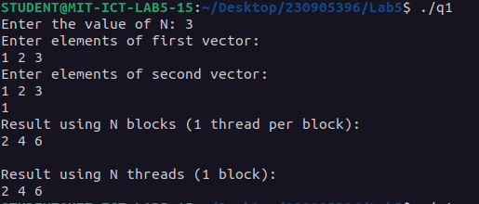
Q2) Implement a CUDA program to add two vectors of length N by keeping the number of threads per block as 256 (constant) and vary the number of blocks to handle N elements.

Code:

#include "cuda_runtime.h"
#include "device_launch_parameters.h"
#include <stdio.h>
#include <stdlib.h>
#include <math.h>

#define THREADS_PER_BLOCK 256

__global__ void vector_addition(int *a, int *b, int *c, int n){
int tid = blockIdx.x * blockDim.x + threadIdx.x;
if(tid < n)
c[tid] = a[tid] + b[tid];
}

int main(){
int n;

printf("Enter the value of N: ");
scanf("%d", &n);

int size = n * sizeof(int);

int *a = (int*)malloc(size);
int *b = (int*)malloc(size);
int *c = (int*)malloc(size);

for(int i = 0; i < n; i++){
a[i] = i;
b[i] = i + 10;
}

int *d_a, *d_b, *d_c;

cudaMalloc((void**)&d_a, size);
cudaMalloc((void**)&d_b, size);
cudaMalloc((void**)&d_c, size);

cudaMemcpy(d_a, a, size, cudaMemcpyHostToDevice);
cudaMemcpy(d_b, b, size, cudaMemcpyHostToDevice);

int blocks = ceil((float)n / THREADS_PER_BLOCK);

vector_addition<<<blocks, THREADS_PER_BLOCK>>>(d_a, d_b, d_c, n);

cudaMemcpy(c, d_c, size, cudaMemcpyDeviceToHost);

printf("\nFirst input array (a):\n");
for(int i = 0; i < n; i++){
printf("%d ", a[i]);
}
printf("\n");

printf("\nSecond input array (b):\n");
for(int i = 0; i < n; i++){
printf("%d ", b[i]);
}
printf("\n");

printf("\nResult after vector addition:\n");
for(int i = 0; i < n; i++){
printf("%d ", c[i]);
}
printf("\n");

cudaFree(d_a);
cudaFree(d_b);
cudaFree(d_c);

free(a);
free(b);
free(c);

return 0;
}

Output:

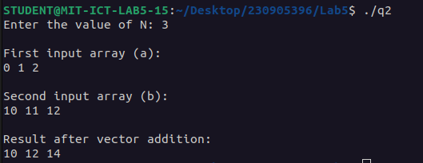

Q3)Write a program in CUDA to process a ID array containing angles in radians to generate
sine of the angles in the output array. Use appropriate function.

Code:

#include "cuda_runtime.h"
#include "device_launch_parameters.h"
#include<stdio.h>
#define PI 3.1415

const int n = 6;

__global__ void angles_to_sine(double *a, double *b){
int tid = threadIdx.x;
if(tid < n) {
b[tid] = sinf(a[tid]);
}
}

int main(){
double *d_a, *d_b;
int size = sizeof(double);

cudaMalloc((void**)&d_a, n * size);
cudaMalloc((void**)&d_b, n * size);

double a[n] = {0, PI/6, PI/4, PI/3, PI/2, PI};
double b[n];

cudaMemcpy(d_a, a, n * size, cudaMemcpyHostToDevice);

angles_to_sine<<<1,n>>>(d_a, d_b);

cudaMemcpy(b, d_b, n * size, cudaMemcpyDeviceToHost);

printf("The 1D array containing sine of angles is: \n");
for(int i = 0; i < n; i++){
printf("sin(%.2lf) = %.2lf \n",a[i],b[i]);
}
printf("\n");

cudaFree(d_a);
cudaFree(d_b);
return 0;
}

Output:
